- Normally in the Hadoop structure, there’s only one Reducer. However, if there’s a hundred nodes in Cluster and amount of data up to 1TB so on data after Mapping will just come only one to the Reducer.
- Why should use ToolRunner?
- Can use ToolRunner in MapReduce driver classes => not mandatory but a best practice.
- ToolRunner uses GenericOptionsParser class internally => Specify configuration options an dspecify items for the Distributed Cache.
- Tearing Down:
- The final automatic cleanup and resource-recovery phase triggered immediately after a MapReduce job finishes (regardless of whether the job SUCCEEDED or FAILED).
- Intermediate Data Cleanup: Hadoop automatically deletes all the temporary key-value files written to the local disks of worker nodes during the Map and Shuffle phases to prevent disk space exhaustion.
- Task JVM Termination: The framework destroys the individual Java Virtual Machine (JVM) instances launched for the Mappers and Reducers, instantly freeing up allocated RAM and CPU back to the cluster.
- Output Committing: The system verifies the final HDFS output directory, removes its internal _temporary folder, and generates a blank _SUCCESS file to signify a clean, uncorrupted run.
- The combiner:
- A mini-reducer
- Runs locally on a single Map’s output
- Output from the combiner is sent to Reducer
- Specifying a Combiner
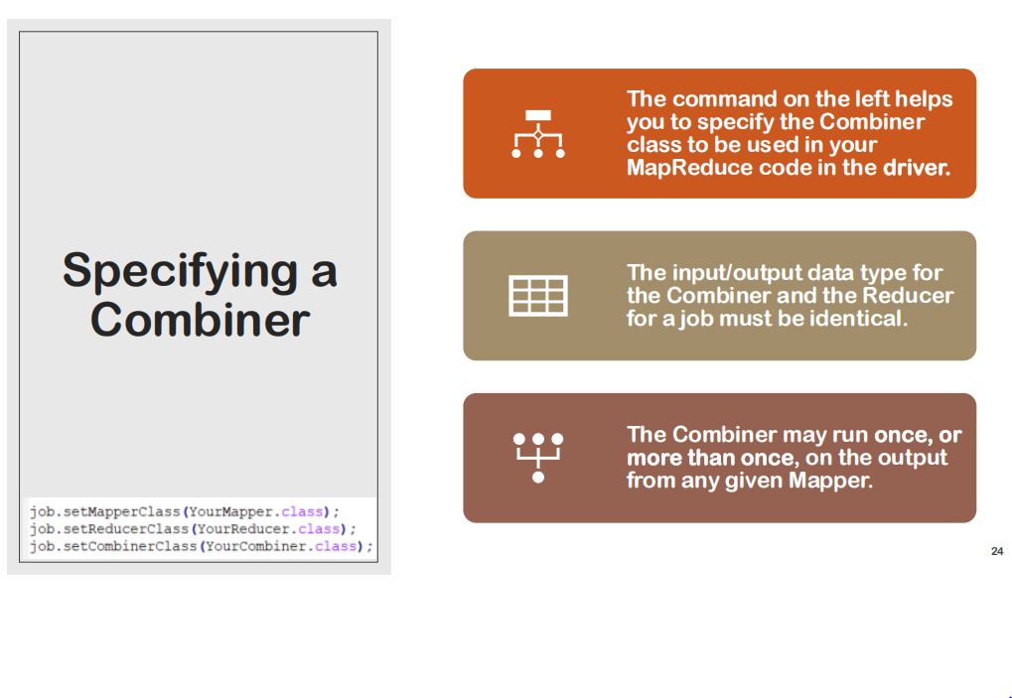
- Workflow of ToolRuner lab:
First, the system receives the folder contains text including “Shakespeare”. Then, in the LetterMapper.java file, caseSensitive = false means play both uppercase() and lowercase() letter. As code illustrated, the output of the mapper will be (firstletter, length of letter)
Next, in the Shuffle and Sort, combine (key,list(value))
Consequently, in the AverageReducer.java. For example if output of shuffle and sort is (h,[4,6,4,2]) so the avergage will be equal to sum/count = 16/4 = 4

